Graduation Frames
Canadian Forces College Branded Merchandise

It’s easy to order your Graduation frames and CFC merchandise. You may order frames online only using the attached order form. Orders placed before 10 May 2019 will not be charged for shipping. Orders received after this date will be charged $25 extra for shipping and may not arrive at the College by the June 7 pickup date.

Graduation frames - four styles priced from $60 (metal frames) - $120 (wood frames):
MDS/MPA RMC
- Briarwood frame – MDS/MPA RMC - 10” x 13” certificate (red mat background) $120
- Briarwood frame with coin – MDS/MPA RMC - 10” x 13” certificate (red mat background) - $190
- Gold Metal frame – MDS/MPA RMC - 10” x 13” certificate - $60
JCSP/NSP CFC
- Briarwood frame – JCSP/NSP (CFC crest) - 11” x 15” certificate (blue mat background) - $120
- Briarwood frame with coin - JCSP/NSP (CFC crest) - 11” x 15” certificate (blue mat background) - $190
- Gold Metal frame - JCSP/NSP (CFC crest) - 11” x 15” certificate (blue mat background) - $60
CSSP CFC
- Briarwood frame – CSSP (CFC crest) – 8 ½” x 11” certificate (blue mat background) - $120
- Briarwood frame with coin - CSSP (CFC crest) – 8 ½” x 11” certificate (blue mat background) - $190
- Gold Metal frame - CSSP (CFC crest) – 8 ½” x 11” certificate (blue mat background) - $60

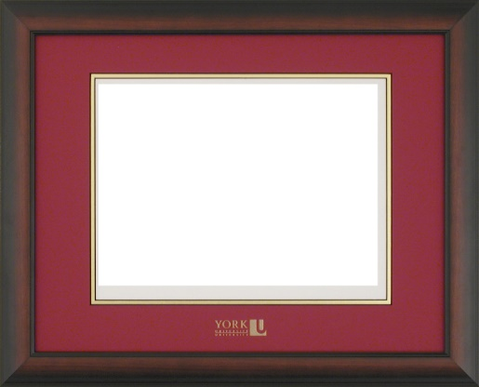 | 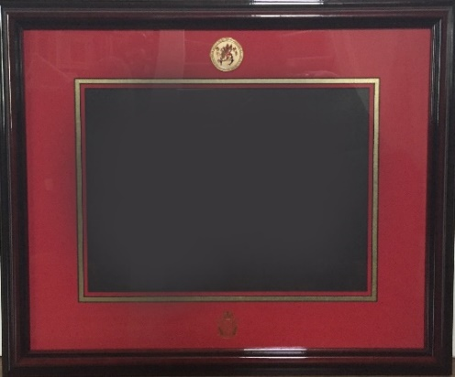 | 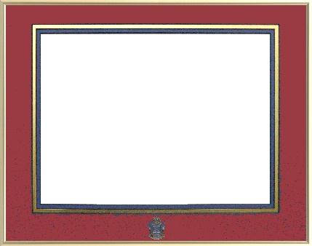
Wood frame available in either red mat or blue mat depending on certificate | Wood frame with coin. Available in either red mat or blue mat depending on certificate | Metal frame available in either red  mat or blue mat depending on certificate
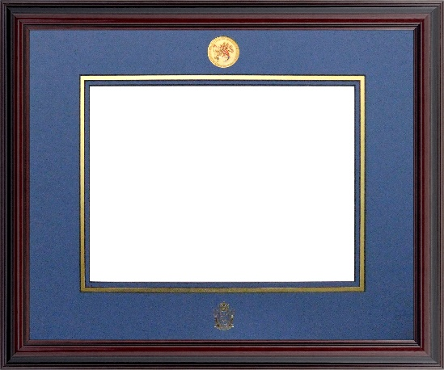

Frames will be available for pickup on 7 June at the College.
CFC branded merchandise (see below) will be shipped directly to you.

Frame prices have not increased from last year.
All profits from sales support the CFC Foundation – and your activities.
ONLINE ORDER FORM FOR CANADIAN FORCES COLLEGE FRAMES

Contact information (fill in the blank fields, save document and email to info@cfcollegefoundation.ca)

RANK,  FIRST NAME | LAST NAME | EMAIL | PHONE | May we contact re CFCF activities  (yes or no)

Select a frame by adding an “X” in the blank field below:

Wood frame - MDS/MPA RMC (red) background $120 | Wood frame - JCSP/NSP CFC (Blue) background $120 | Wood frame with coin - MDS/MPA RMC (red) background $190 | Wood frame with coin- JCSP/NSP CFC (Blue) background $190 | Metal frame - MDS/MPA RMC (red) background $60 | Metal frame - JCSP/NSP CFC (blue) background $60

Delivery options (select one):

☐ Pickup at Canadian Forces College on 7 June at the College
☐Ship to the following address for an extra $25:

Once we receive your order, we will email you an invoice and you can pay directly online.

CFC BRANDED MERCHANDISE
Canadian Forces College branded merchandise can be ordered from Canex at any time by clicking here.
These items will be shipped directly to you.

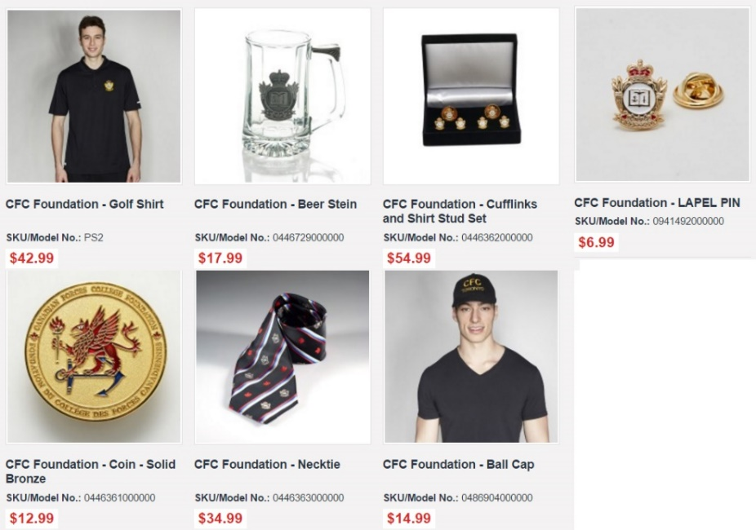

Thank you for supporting your Foundation.
To find out more about the Foundation please visit cfcollegefoundation.ca

