CANADIAN FORCES COLLEGE BRANDED MERCHANDISE AND GRADUATION FRAMES

It’s easy to order your frames for your Graduation certificates. Here’s how:

Complete the form below and email to info@cfcollegefoundation.ca.

Graduation frames – three styles priced from $60 (metal frames) - $120 (wood frames) or $190 (wood frames with CFC Foundation coin).
 |  | 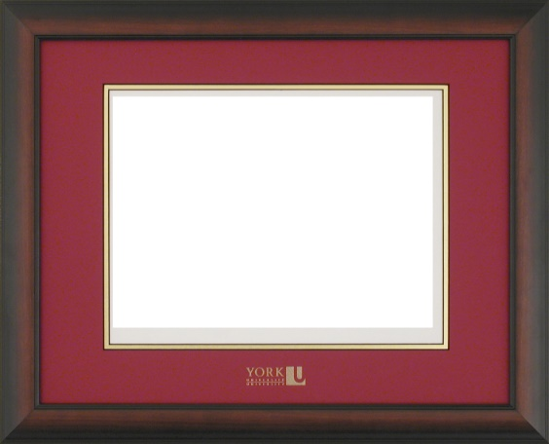 |  | 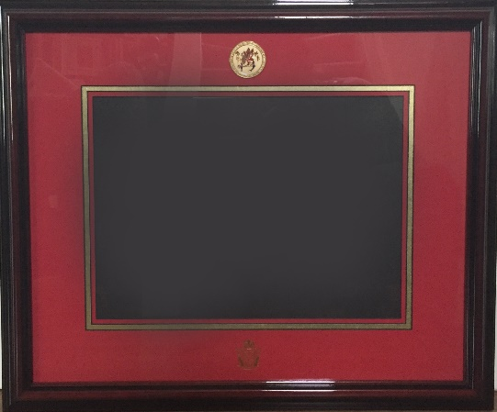
BRANDED MERCHANDISE
Canadian Forces College branded merchandise will also be on display. There will be a limited number of items for sale at the AHOM; however, you may order merchandise from Canex at any time by clicking here. CFC branded merchandise ordered from Canex will be shipped directly to you.

Thank you for supporting your Foundation. To find out more about the Foundation please visit cfcollegefoundation.ca
ONLINE ORDER FORM FOR CANADIAN FORCES COLLEGE FRAMES

Contact information (fill in the blank fields, save document and email to info@cfcollegefoundation.ca)

RANK,  FIRST NAME | LAST NAME | EMAIL | PHONE | May we contact re CFCF activities  (Enter yes or no)

Select a frame by adding an “X” in the blank field below:

Wood frame - MDS/MPA RMC (red) background $120 | Wood frame - JCSP/NSP CFC (Blue) background $120 | Wood frame with coin - MDS/MPA RMC (red) background $190 | Wood frame with coin- JCSP/NSP CFC (Blue) background $190 | Metal frame - MDS/MPA RMC (red) background $60 | Metal frame - JCSP/NSP CFC (blue) background $60

Delivery:

Ship to the following address for an extra $25:

Once we receive your order, we will email you an invoice and you can pay directly online.

